Remote Method Invocation (RMI)

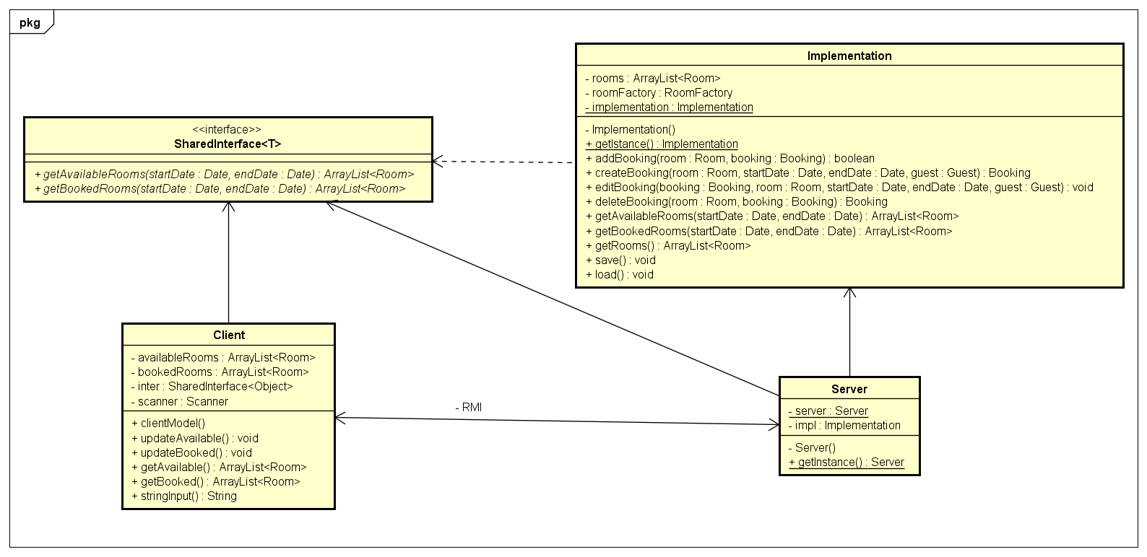The Java Remote Method Invocation (RMI) system allows an object running in one Java virtual machine to invoke methods on an object running in another Java virtual machine.

**Server :**

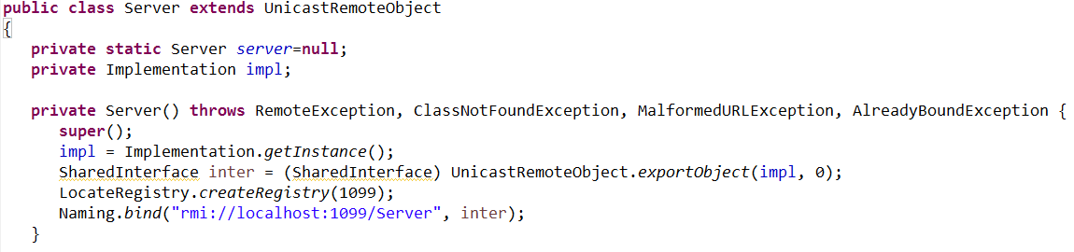

**Client :**

